Online Payments Fraud Detection Using Machine Learning

Project Description:
One of the most critical factors influencing today’s digital economy and financial ecosystem is the security of online payment systems. With the rapid growth of digital transactions, mobile banking, UPI, credit/debit cards, and e-commerce platforms, the risk of fraudulent activities has significantly increased. Fraud detection has become a major concern for banks, financial institutions, and payment gateways across the globe. As we know, detecting fraudulent transactions is extremely crucial, and a variety of analytical and computational techniques are used to identify suspicious behavior patterns. Fraud risk assessment has therefore become one of the core operational functions of modern financial systems.
The prediction of fraudulent transactions is one of the most challenging tasks for financial institutions because fraudsters continuously evolve their strategies. However, by forecasting and identifying fraudulent transactions in real-time, organizations can significantly reduce financial losses, protect customer assets, and enhance trust in digital payment systems. Early detection helps in minimizing chargebacks, preventing unauthorized access, and maintaining the integrity of transaction networks. This makes the study of online payment fraud detection highly important in the current digital era. Machine Learning techniques play a vital role in analyzing large volumes of transaction data and identifying hidden patterns that indicate fraudulent behavior.
In this project, we use supervised machine learning classification algorithms such as Decision Tree, Random Forest, Logistic Regression, and Gradient Boosting to classify transactions as Fraudulent or Legitimate. The dataset is trained and tested using these algorithms, and performance is evaluated using metrics such as accuracy, precision, recall, F1-score, and ROC-AUC. Based on comparative analysis, the best-performing model is selected and saved in .pkl format. The saved model is then integrated into a Flask-based web application to provide real-time fraud prediction. The system can further be deployed on cloud platforms for scalable and secure access.

Technical Architecture:
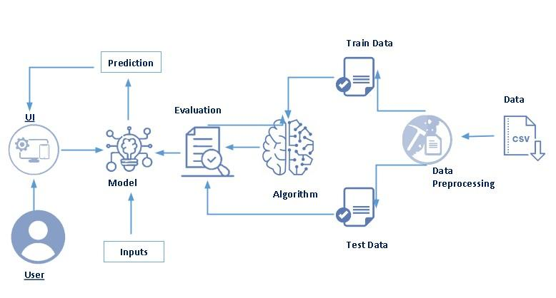
Pre-Requisites
To successfully complete this project, the following software tools, libraries, and technical knowledge are required.
Software Requirements
Python Environment:
- Python 3.8 or above
- Anaconda Navigator (recommended) or standard Python installation
IDE / Development Tools:
- VS Code
- PyCharm
- Jupyter Notebook (for model training)
Streamlit Framework
Streamlit is used to build and deploy the interactive web interface for fraud prediction.
Install Streamlit using:
pip install streamlit
To run the application:
streamlit run app.py
Required Python Packages
Open Anaconda Prompt or Command Prompt and install:
- pip install numpy
- pip install pandas
- pip install scikit-learn
- pip install matplotlib
- pip install seaborn
- pip install scipy
- pip install pickle-mixin
- pip install imbalanced-learn
- pip install streamlit
Package Usage in This Project
- NumPy – Numerical operations
- Pandas – Data preprocessing and manipulation
- Scikit-learn – Model building and evaluation
- Matplotlib & Seaborn – Data visualization
- SciPy – Statistical operations
- Imbalanced-learn – SMOTE for handling imbalanced fraud data
- Pickle – Saving trained ML model (.pkl file)
- Streamlit – Creating interactive web application UI
Prior Knowledge
To effectively implement this project, the following concepts are required:
Machine Learning Concepts
- Supervised Learning
- Binary Classification
- Model Training and Testing
- Overfitting and Underfitting
- Bias-Variance Tradeoff
Algorithms Used in This Project
- Random Forest
Understanding how these algorithms classify transactions into Fraudulent and Legitimate categories is essential.
Model Evaluation Metrics
Fraud detection is an imbalanced classification problem. Therefore, knowledge of the following metrics is important:
- Accuracy
- Precision
- Recall
- F1-Score
- Confusion Matrix
- ROC-AUC Score
In fraud detection systems, Recall is especially important to minimize false negatives (missing actual fraud cases).
Data Preprocessing Techniques
- Handling Missing Values
- Encoding Categorical Variables
- Feature Scaling
- Handling Imbalanced Dataset using SMOTE
- Train-Test Split
Streamlit Basics
Basic understanding of:
- Creating interactive input fields (st.number_input, st.selectbox)
- Displaying predictions using st.success / st.error
- Loading saved model using pickle
- Running Streamlit app locally
- Deploying Streamlit app (optional cloud deployment)
Project Objectives
By the end of this project, you will:
- Understand the fundamental concepts and techniques used in Machine Learning for fraud detection.
- Gain a comprehensive understanding of transactional financial data and its behavioral patterns.
- Learn how to preprocess real-world datasets, including handling missing values, outliers, and imbalanced classes.
- Develop skills in performing data visualization and exploratory data analysis (EDA).
- Understand how to build, train, and evaluate classification models for binary fraud detection.
- Learn how to select the best-performing model using appropriate evaluation metrics.
- Deploy a trained Machine Learning model using Streamlit to create an interactive web application.
- Build an end-to-end real-time fraud prediction system.
Project Flow
The overall workflow of the Online Payments Fraud Detection System is as follows:
- The user interacts with the Streamlit-based web interface and enters transaction details.
- The entered transaction data is preprocessed and passed to the trained Machine Learning model.
- The integrated model analyzes the transaction based on learned fraud patterns.
- The model predicts whether the transaction is Fraudulent or Legitimate.
- The prediction result is displayed instantly on the Streamlit UI.
Activities to Accomplish the Project
To successfully implement this project, the following stages are completed:
● Data Collection
- Collect the online payments fraud dataset from trusted sources (e.g., Kaggle).
- Understand the structure of the dataset, including features such as transaction amount, balances, transaction type, and fraud label.
● Visualizing and Analyzing Data
Exploratory Data Analysis (EDA) is performed to understand transaction behavior.
○ Univariate Analysis
- Analyze individual features like transaction amount, balance differences, and fraud count.
- Use histograms, count plots, and box plots to understand distribution patterns.
○ Bivariate Analysis
- Study the relationship between two variables such as:
  - Transaction Amount vs Fraud
  - Transaction Type vs Fraud
  - Balance Change vs Fraud
- Identify patterns that distinguish fraudulent transactions.
○ Multivariate Analysis
- Use correlation matrices and heatmaps to analyze relationships among multiple features.
- Identify highly correlated variables that influence fraud prediction.
○ Descriptive Analysis
- Use statistical summaries (mean, standard deviation, min, max, percentiles).
- Understand dataset characteristics using describe() and info() functions.
● Data Pre-Processing
Data preprocessing ensures the dataset is suitable for training machine learning models.
○ Checking for Null Values
- Identify missing values using isnull().sum().
- Handle missing values using mean, median, or mode if necessary.
○ Handling Outliers
- Detect outliers using boxplots and IQR method.
- Treat extreme transaction amounts that may skew model performance.
○ Handling Categorical Data
- Encode categorical features (e.g., transaction type) using label encoding or one-hot encoding.
○ Handling Imbalanced Data
- Apply SMOTE (Synthetic Minority Oversampling Technique) to balance fraud and non-fraud classes.
○ Splitting Data into Train and Test Sets
- Separate features (X) and target variable (y).
- Use train_test_split() to divide dataset for training and testing.
● Model Building
Multiple classification algorithms are trained and compared.
○ Import Model Libraries
- Logistic Regression
- Decision Tree
- Random Forest
- Gradient Boosting
○ Initializing the Model
- Define model parameters.
- Configure hyperparameters if required.
○ Training and Testing the Model
- Fit the model on training data.
- Predict outcomes on test data.
○ Evaluating Model Performance
- Evaluate using:
  - Accuracy
  - Precision
  - Recall
  - F1-Score
  - Confusion Matrix
  - ROC-AUC Score
Special emphasis is given to Recall and Precision, as fraud detection requires minimizing false negatives and false positives.
○ Save the Model
- Save the best-performing model in .pkl format using pickle.
- This saved model is used for deployment in Streamlit.
● Application Building (Streamlit-Based)
Instead of HTML and Flask, this project uses Streamlit for deployment.
○ Build Streamlit Interface
- Create input fields for transaction details using:
  - st.number_input()
  - st.selectbox()
- Create prediction button using st.button().
○ Build Python Application Code
- Load saved model using pickle.
- Capture user input.
- Convert input into model-compatible format.
- Display prediction result using:
  - st.success() for legitimate transactions
  - st.error() for fraudulent transactions

Project Structure:
Create the Project folder which contains files as shown below
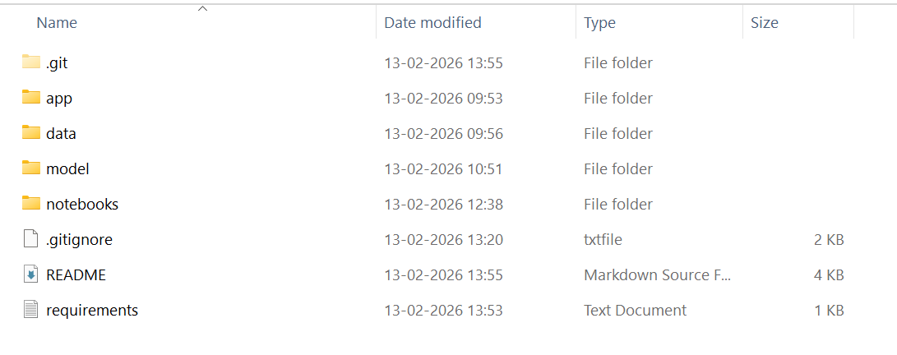
- We are building a Streamlit application, which does not require separate HTML template files. The entire user interface is created inside the app.py file using Streamlit components, and this script controls both the frontend interface and backend logic.
- fraud_model.pkl is our saved trained machine learning model. This model is loaded inside app.py and used to perform real-time fraud prediction when the user enters transaction details.
- The training folder contains all model development files, including data preprocessing, model building, evaluation, and comparison scripts or notebooks used during the training phase.
- The data folder contains the dataset used for training and testing the fraud detection model.
- The requirements.txt file contains all necessary Python libraries required to run the project successfully in any environment.
Milestone 1: Data Collection
Machine Learning models rely heavily on quality data, as data is the foundation for training, testing, and evaluating algorithms. In fraud detection systems, large volumes of transactional data are essential to identify patterns that differentiate legitimate transactions from fraudulent ones. Therefore, collecting a reliable and well-structured dataset is the first and most critical step in building the Online Payments Fraud Detection system.
Activity 1: Download the Dataset
There are several trusted open-source platforms available for collecting datasets, such as:
- Kaggle
- UCI Machine Learning Repository
- Government Open Data Portals
For this project, we use an Online Payments Fraud Detection dataset downloaded from Kaggle. The dataset contains transactional information such as:
- Transaction Type
- Transaction Amount
- Old Balance
- New Balance
- Account Details
- Time Step
- Fraud Label (Target Variable – 0 for Legitimate, 1 for Fraud)
The dataset is typically available in .csv format (e.g., fraud.csv).
After downloading:
- Place the dataset inside the data/ folder of the project directory.
- Load the dataset using Pandas in Python:
- import pandas as pd
- df = pd.read_csv("data/fraud.csv")
- Verify the structure of the dataset using:
- df.head()
- df.info()
The collected dataset is then used for:
- Exploratory Data Analysis (EDA)
- Data Preprocessing
- Model Training and Evaluation
Proper data collection ensures that the fraud detection model can learn meaningful transaction patterns and make accurate predictions.
Milestone 2: Visualizing and Analyzing the Data
After downloading the Online Payments Fraud dataset, the next step is to explore and understand the data using visualization and statistical analysis techniques. Exploratory Data Analysis (EDA) helps identify patterns, anomalies, correlations, and class imbalance, which are critical in fraud detection systems.
Although many advanced techniques exist for analyzing data, in this project we focus on essential and effective visualization methods.
Activity 1: Importing the Libraries
First, we import the required libraries for data manipulation and visualization.
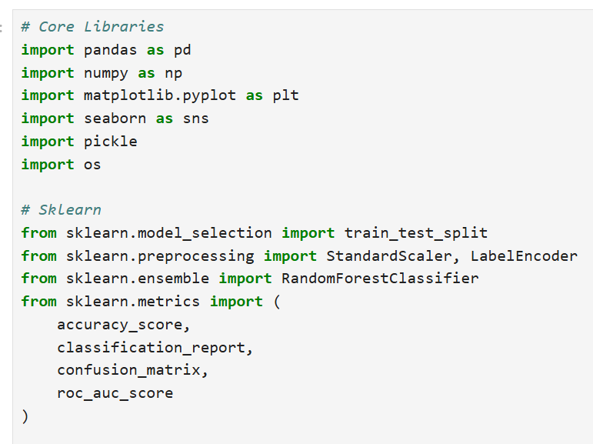
- Pandas → Data manipulation
- NumPy → Numerical computations
- Matplotlib & Seaborn → Data visualization
Activity 2: Reading the Dataset
The dataset is available in .csv format (e.g., fraud.csv). We use the read_csv() function from pandas to load it.
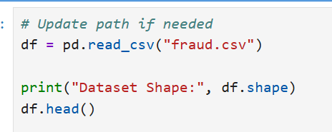
This helps identify:
- Number of rows and columns
- Data types of features
- Presence of missing values
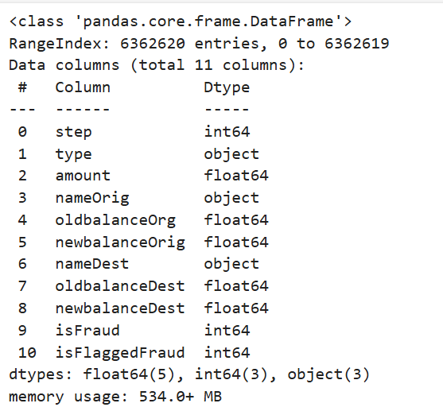
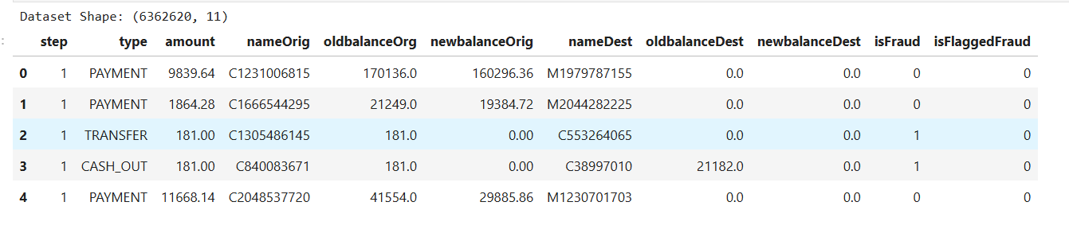
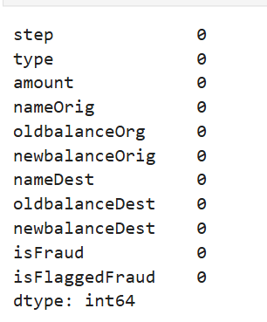
Activity 3: Univariate Analysis
Univariate analysis focuses on analyzing a single feature at a time.
● Count Plot (Categorical Features)
For categorical variables like:
- Transaction Type
- Fraud Label (0 = Legitimate, 1 = Fraud)
sns.countplot(x="isFraud", data=df)
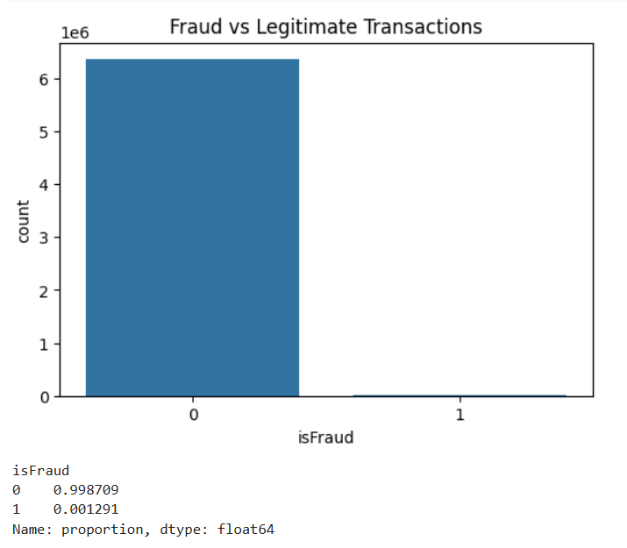
Observation:
- Fraud transactions are significantly fewer than legitimate transactions.
- This confirms that the dataset is highly imbalanced.
A count plot behaves like a histogram for categorical variables and shows the frequency of each category.
Activity 4: Bivariate Analysis
Bivariate analysis studies the relationship between two variables.
● Transaction Type vs Fraud
sns.countplot(x="type", hue="isFraud", data=df)
Insight:
- Certain transaction types (e.g., transfer or cash-out) may show higher fraud occurrences.
● Transaction Amount vs Fraud
sns.boxplot(x="isFraud", y="amount", data=df)
Insight:
- Fraudulent transactions may involve unusually high transaction amounts compared to legitimate ones.
● Balance Changes vs Fraud
We analyze how balance differences influence fraud detection.
Fraudulent transactions often show abnormal balance variations.
Activity 5: Multivariate Analysis
Multivariate analysis identifies relationships among multiple features simultaneously.
● Correlation Matrix
plt.figure(figsize=(10,8))
sns.heatmap(df.corr(), annot=True, cmap="coolwarm")
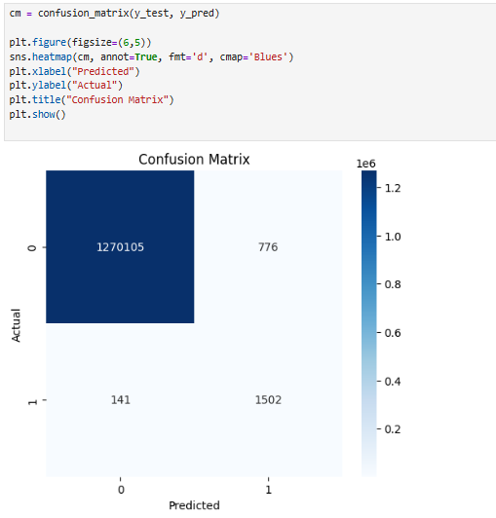
Insight:
- Highly correlated variables help in identifying important features.
- Strong relationships between balance-related features may influence fraud detection.
● Swarm Plot / Scatter Plot
We can analyze:
- Transaction Amount
- Balance Differences
- Fraud Label
This helps visually distinguish patterns between fraud and non-fraud transactions.
Activity 6: Descriptive Analysis
Descriptive statistics provide numerical summaries of the dataset.
df.describe()
This gives:
- Mean
- Standard deviation
- Minimum and maximum values
- Percentiles
For categorical features:
df["type"].value_counts()
This helps identify dominant transaction categories.
Milestone 3: Data Pre-Processing
After understanding the dataset through visualization and analysis, the next step is data preprocessing. The raw dataset collected from external sources is not directly suitable for training a Machine Learning model because it may contain missing values, imbalanced classes, inconsistent formats, or scale variations. Therefore, preprocessing is required to clean and transform the data to improve model performance.
The preprocessing stage in the Online Payments Fraud Detection project includes the following steps:
- Handling missing values
- Handling categorical data
- Handling outliers
- Balancing the dataset
- Scaling techniques
- Splitting dataset into training and testing sets
Note: Depending on the dataset characteristics, some steps may not be required.
Activity 1: Checking for Null Values
Before performing any transformation, we analyze the structure of the dataset.
To check the shape of the dataset:
df.shape
To check data types and basic information:
df.info()
To check for missing values:
df.isnull().sum()
If missing values are present:
- Numerical columns are filled using mean or median values.
- Categorical columns are filled using the most frequent value (mode).
However, in many fraud detection datasets, missing values may already be cleaned. If no null values are found, this step can be skipped.
Activity 2: Handling Categorical Values
Machine Learning algorithms require numerical input. If the dataset contains categorical features such as:
- Transaction Type
- Account Type
- Payment Method
These features must be converted into numerical format.
Common encoding techniques include:
- Label Encoding
- One-Hot Encoding
In this project, categorical features such as transaction type are converted into numerical form using encoding techniques like:
df = pd.get_dummies(df, drop_first=True)
This ensures that the model can process categorical transaction attributes effectively.
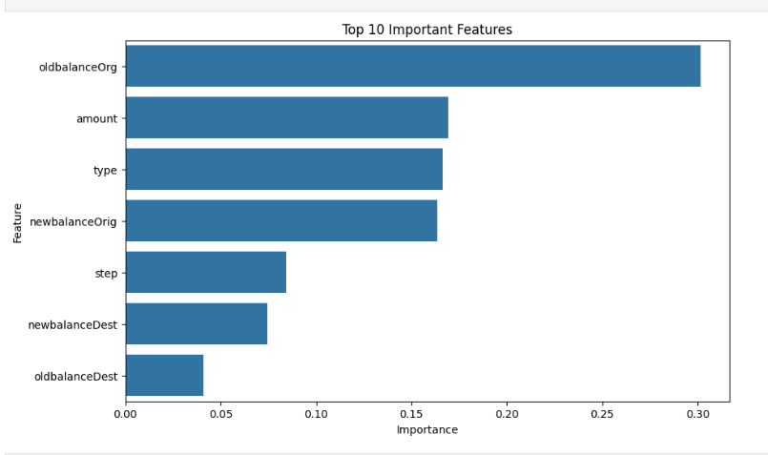
Activity 3: Handling Imbalanced Dataset (Data Balancing)
Fraud detection datasets are highly imbalanced because fraudulent transactions are much fewer than legitimate transactions. Training a model on such data can lead to biased predictions toward the majority class.
To solve this issue, we apply:
SMOTE (Synthetic Minority Oversampling Technique)
SMOTE generates synthetic samples for the minority class using a K-Nearest Neighbors approach.
from imblearn.over_sampling import SMOTE
smote = SMOTE(random_state=42)
X_resampled, y_resampled = smote.fit_resample(X, y)
Before SMOTE:
- Legitimate transactions >> Fraud transactions
After SMOTE:
- Both classes become balanced
This improves the model’s ability to correctly detect fraud cases.
Activity 4: Handling Outliers
Fraud datasets often contain extreme transaction amounts that may influence model performance.
Outliers can be detected using:
- Boxplots
- Interquartile Range (IQR) method
If necessary, extreme values can be capped or treated using transformation techniques to reduce skewness.
Activity 5: Scaling the Data
Scaling is important because features such as:
- Transaction Amount
- Old Balance
- New Balance
may exist in different numerical ranges.
Models like:
- Logistic Regression
- KNN
- Gradient-based algorithms
perform better when data is scaled.
We use StandardScaler:
from sklearn.preprocessing import StandardScaler
scaler = StandardScaler()
X_scaled = scaler.fit_transform(X_resampled)
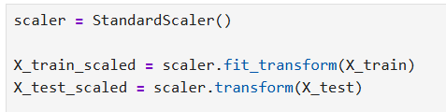
After scaling, the dataset is converted back to a structured format if required.
Activity 6: Splitting Data into Train and Test Sets
Before training the model, the dataset is divided into input features (X) and target variable (y).
X = df.drop("isFraud", axis=1)
y = df["isFraud"]
Then we split the dataset:
from sklearn.model_selection import train_test_split
X_train, X_test, y_train, y_test = train_test_split(
X_scaled, y_resampled,
test_size=0.2,
random_state=42
)
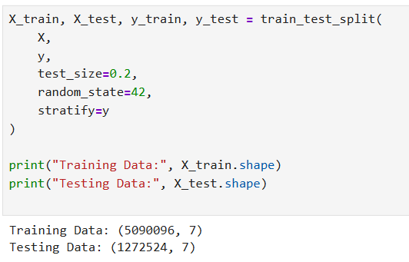
- Training set → Used to train the model
- Testing set → Used to evaluate model performance
Milestone 4: Model Building
After completing data preprocessing, the dataset is ready for model training. Since Online Payments Fraud Detection is a binary classification problem (Fraudulent / Legitimate), a suitable supervised learning algorithm is required.
For this project, we have implemented the Random Forest Classifier as the primary model for fraud detection due to its high accuracy, robustness, and ability to handle imbalanced datasets effectively.
Activity 1: Random Forest Model
A function is created where training and testing datasets are passed as parameters.
Inside the model-building process:
- The RandomForestClassifier from sklearn.ensemble is initialized.
- The model is trained using the .fit() method on the training dataset.
- Predictions are generated using the .predict() method on the test dataset.
- Performance is evaluated using:
  - Confusion Matrix
  - Classification Report
  - Accuracy Score
  - Precision
  - Recall
  - F1-Score
Example implementation:
from sklearn.ensemble import RandomForestClassifier
rf_model = RandomForestClassifier(random_state=42)
rf_model.fit(X_train, y_train)
y_pred = rf_model.predict(X_test)
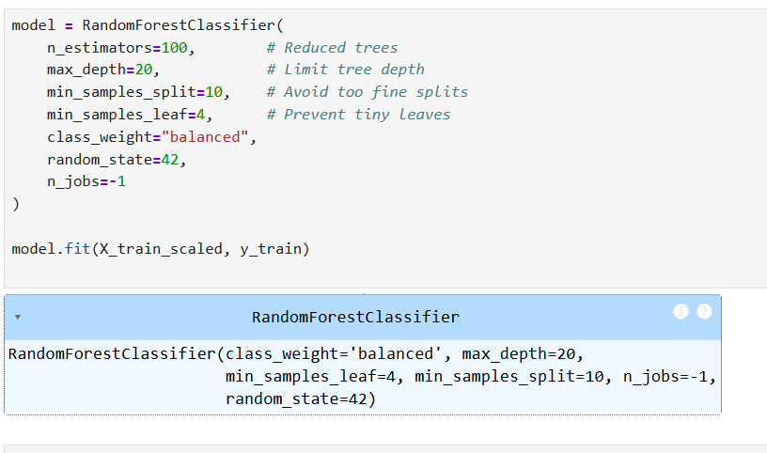
Why Random Forest?
Random Forest is selected because:
- It is an ensemble learning method that combines multiple decision trees.
- It reduces overfitting compared to a single Decision Tree.
- It performs well on structured/tabular datasets like transaction data.
- It handles feature importance effectively.
- It works well even when the dataset contains noise and complex patterns.
Since fraud detection requires identifying subtle transaction patterns, Random Forest provides strong predictive performance and stability.
Model Evaluation
The model performance is evaluated using:
- Confusion Matrix → To analyze True Positives, True Negatives, False Positives, and False Negatives.
- Precision → To measure how many predicted fraud cases are actually fraud.
- Recall → To measure how many actual fraud cases are correctly detected.
- F1-Score → Harmonic mean of Precision and Recall.
In fraud detection systems, Recall is very important because missing a fraud case (False Negative) can lead to financial loss.
Cross-Validation
To ensure that the model generalizes well to unseen data, cross-validation is performed using:
from sklearn.model_selection import cross_val_score
scores = cross_val_score(rf_model, X, y, cv=5)
- 5-fold cross-validation is used.
- The average score confirms the stability of the Random Forest model.
Saving the Model
After confirming satisfactory performance, the trained model is saved in .pkl format for deployment in the Streamlit application.
import pickle
pickle.dump(rf_model, open("fraud_model.pkl", "wb"))
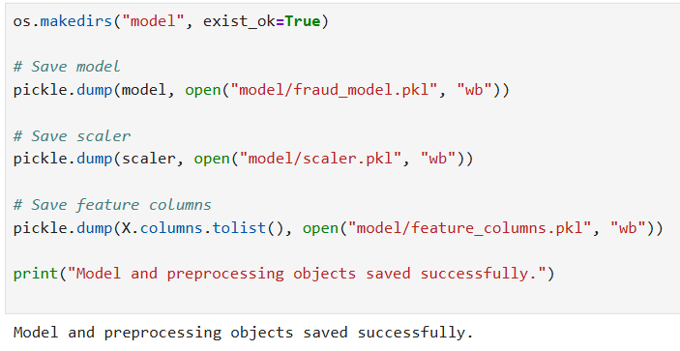
This saved model is later loaded inside app.py for real-time fraud prediction.
Milestone 5: Application Building
In this section, we build a web-based application integrated with the trained Random Forest fraud detection model. A user interface is developed using Streamlit where users can enter transaction details. These entered values are passed to the saved model, and the prediction (Fraudulent / Legitimate) is displayed instantly on the screen.
Unlike Flask applications, Streamlit does not require separate HTML pages or server-side routing. The entire UI and backend logic are handled within a single Python file (app.py).
This section includes the following tasks:
- Building Streamlit User Interface
- Integrating the saved Machine Learning model
- Displaying real-time prediction results

Activity 1: Building the Streamlit User Interface
The user interface is created directly in app.py using Streamlit components.
The UI includes:
- Title and project description
- Input fields for transaction details
- Prediction button
- Output result display
Example UI components used:
- st.title() → Display application title
- st.number_input() → Accept numerical transaction inputs
- st.selectbox() → Accept categorical transaction type
- st.button() → Trigger prediction
- st.success() / st.error() → Display prediction result
Streamlit automatically generates the web interface without requiring separate HTML files.

Activity 2: Building the Python Application Code
Step 1: Import Required Libraries
import streamlit as st
import pickle
import numpy as np

Step 2: Load the Saved Model
The trained Random Forest model (fraud_model.pkl) is loaded:
model = pickle.load(open("fraud_model.pkl", "rb"))

Step 3: Capture User Input
User inputs such as:
- Transaction Amount
- Old Balance
- New Balance
- Transaction Type
are collected through Streamlit input fields.
These inputs are converted into a numerical array format suitable for the model:
input_data = np.array([[amount, old_balance, new_balance, type_encoded]])

Step 4: Make Prediction
When the user clicks the Predict button:
prediction = model.predict(input_data)
If prediction output is:
- 0 → Legitimate Transaction
- 1 → Fraudulent Transaction
The result is displayed using:
st.success("Legitimate Transaction")
or
st.error("Fraudulent Transaction Detected")

Activity 3: Running the Application
To execute the Streamlit application:
- Open Anaconda Prompt or Command Prompt
- Navigate to the project folder
- Run the following command:
streamlit run app.py
- Streamlit automatically opens a browser window at:
http://localhost:8501
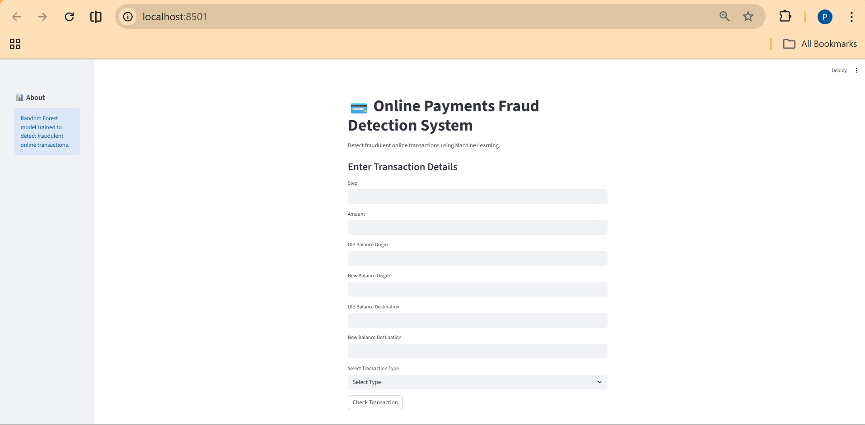

- Enter transaction details and click the Predict button.

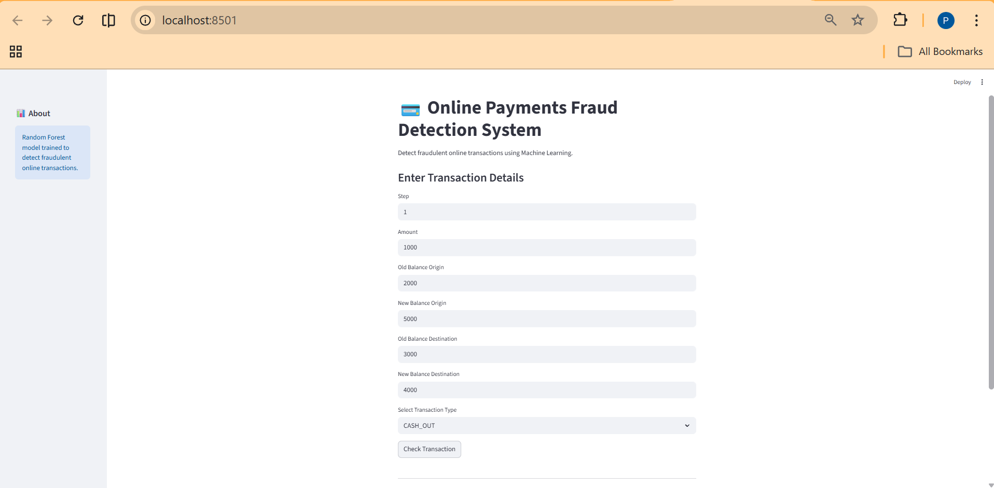

- The fraud prediction result is displayed instantly.

